Configuring Financial Holds Solution

Exercise: Configuration

Spec 1

Requirement(s)

The customer wants financial holds to be in place when a claim is in litigation.

Specifications

1. If a claim is in litigation, no indemnity payments are allowed, but expense payments are allowed with a warning.
2. A claim's litigation status can be found on the **Summary🡪Claim Status** screen, under the **High Risk** Indicators header.
3. The litigation status is stored in **the Claim.LitigationStatus** field.

InGWClaimFinancialsHoldsEnhancement.gsx, add one line to the “applyFinancialHolds()” function (which should be on line 11).

function applyFinancialHolds() : Boolean {

return this.CoverageInQuestion

or this.IncidentReport

or not this.Policy.Verified

or this.LitigationStatus==LitigationStatus.TC_LITIGATED

}

Add a Transaction Set Validation rule that blocks claim cost payments and issues an appropriate error message. It issues a warning for other transaction types.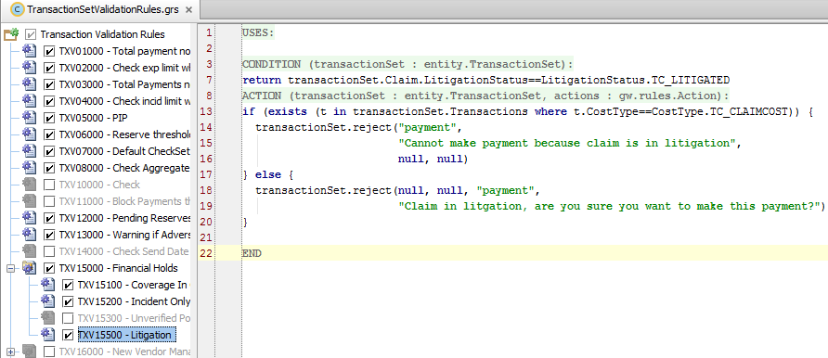

CONDITION:

return transactionSet.Claim.LitigationStatus==LitigationStatus.TC_LITIGATED

ACTION:

if (exists (t in transactionSet.Transactions where t.CostType==CostType.TC_CLAIMCOST)) {

transactionSet.reject("payment",

"Cannot make payment because claim is in litigation",

null, null)

} else {

transactionSet.reject(null, null, "payment",

"Claim in litgation, are you sure you want to make this payment?")

}